**Sample Test of Greedy Program**

1. **Inputs Given to the Program**

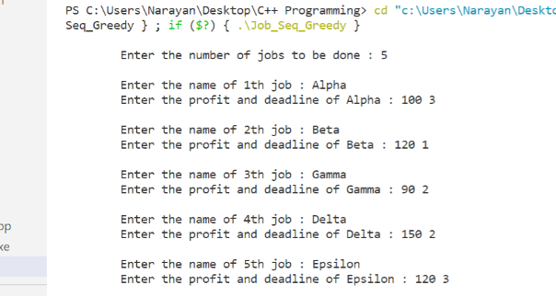

1. **Details of Input**

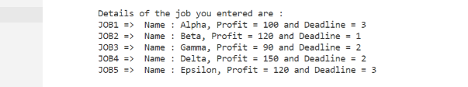

1. **Job Sequence for Maximum Profit, Maximum Profit and time taken in the Scheuling Process**

